ECON 3140A Financial Data Analysis

Profitability and Applicability of the MACD-ADX

Mixed Strategy

—— using constituent stocks from Shanghai Index, DAX Index and Nasdaq Index as sample

Term Paper by LI Zhongying

PENG Zhichao

YIN Weize

ZHANG Xinyuan

**Abstract**

This study is conducted to test the practical feasibility in equity market of the trading rule by synthetically considering two oscillators MACD and ADX, as well as its different performances in different markets in order to find out the applicability under different conditions. We found the mixed strategy outperformed the pure MACD strategy and the buy-and-hold strategy in both China and Germany stock markets, but the opposite in U.S. market, over an investment horizon from 2006 to 2016, which can be explained by market volatility.

1. **Introduction**

Technical analysis tries to earn an abnormal return using historical data to generate buy and sell signals. It is based on the assumption that even weak form market efficiency hypothesis does not work and not all the information has been reflected in the current stock price. Technical analysts utilize diverse indicators to capture market movement direction and reversal patterns. A most used indicator is MACD (Moving Average Convergence/ Divergence), using the difference between short term EMA (exponential moving average) and long term EMA to detect the possible reversals of the current trend. Buy and sell signals will be generated when the MACD line crosses its signal line which indicates a trend reversal in the future. Following this MACD trading rule will the investors have a better possibility to buy at uptrend and sell at downtrend, which will help improve profits and cut losses.

The trading rule has been proven profitable through lots of literature and is practiced by investors all around the world. (Lee, & Hwang, 2016) However, there is still possible risk that the rule may not provide us with a strong enough reversed trend and hence will cause damage to the investment (Lee, & Hwang, 2016). In order to further improve the rule, we suggest add another indicator Average Directional Index (ADX) to test the strength of the reversed trend. ADX shows how strong the current trend is and by investing in a strong uptrend we will have a larger possibility of a positive return. The profitability of the new combined trading rule will be tested in the study, as well as its performances in different markets, which suggests the application guidelines.

1. **Methodology and Data**
   1. **Indicators**
      1. **MACD**

MACD shows the relationship between two moving averages. By analyzing the differences between the short-term EMA and long-term EMA, investors can obtain insights of price changes. Since the indicator has the advantages of simplicity and efficiency over others, many Investors prefer to use it when analyzing the stock market. (Lee, & Hwang, 2016)

MACD is calculated though the following equations:

$${EMA}_{t}={Closing Price}_{t}×\frac{2}{Period+1}+{EMA}_{t-1}×(1-\frac{2}{Period+1})$$

$${Signal}_{t}={MACD}_{t}×\frac{2}{Period+1} +{Signal}_{t-1}×(1-\frac{2}{Period+1})$$

MACD line = Short Term EMA − Long Term EMA

Signal line = n day EMA of MACD line

In our trading practice, we define short term as 12 days and long term as 26 days. Therefore, the calculation of EMA begins at t =12. Furthermore, we define n as 9. So the calculation of the signal will start from the 34th day.

* + 1. **ADX**

The main purpose of the other indicator, Average Directional Index (ADX) is to measure the strength and weakness of a stock’s trend. A higher ADX indicates a stronger uptrend. (Gujral & Ashwani, 2005). By combining the two indicators, we will have the advantages of them two. MACD can be used to find a trend and ADX can evaluate the trend’s strength.

* 1. **Trading Rules and Annual Return**

We use Strategy 1 to represent the trading strategy utilizing the mixed rule of MACD and ADX. Buying signals are generated when

MACDk-1 –Signalk-1< 0 & MACD k – Signal k> 0,

ADXt-1< 20 & ADX t >20,

where k ≤ t.

Selling signals are generated when

MACDk-1 –Signalk-1>0 & MACD k – Signal k< 0

The Trading rules can be explained as follows: When MACD line crosses the signal line form below. It is just a potential buy signal. We just hold the stock and wait for the other indicator ADX rising from below to above the 20 level. Only when both requirements are fulfilled can the stock be bought. As for the selling signals, if MACD crosses signal line from above, the stock will be sold. The reason why buy signal and sell signal are in different conditions is that MACD reflects the price change faster than ADX does. (Kotowski , Szlachcic, & Wa, 2010) In most cases investors are risk-averse and afraid of losses, so they will be more cautious when buying a stock while sell it without much consideration if they find a strong downtrend signal. (L.&Y., 2016). So mixed trading rules are more realistic than a pure MACD trading rule.

We use annualized return to measure the performances of different trading rules and the calculation of annual rate of return is defined as follow:

$$R={[(1+r_{1}) ×(1+r_{2})×……×(1+r_{n})]}^{\frac{250}{T}}-1,$$

where $1+r_{i}= \frac{S(k)}{B(k)}$,

S(k) and B(k) being the selling and buying prices of the transaction;

r is the number of transactions in the sample;

T is the number of trading days in the sample.

* 1. **Data**

This paper collects past price data of seven constituent stocks from each of the three main stock indices around the world respectively, Shanghai securities composite index, German DAX 30 index and Nasdaq index. The three markets are in different development stages and regions. Therefore, they are representative through their unique characteristics (Roll, 1992). By this way we can test our trading rules’ effectiveness and feasibility. The chosen stocks must meet two criteria: First, its capitalization should rank the top among constituent stocks. Second, it must have historical transition records from November 22rd 2006 to November 22rd 2016. The data is extracted from the Yahoo Finance website and the details are as follows:

**Table 1. Data Information**



1. **Results and Conclusions**
   1. **Profitability of MACD-ADX Mixed Strategy and Pure MACD Strategy**

**3.1.1 Comparison of two strategies**

Table 2 shows the annualized return rate of 21 constituent stocks from Shanghai Index, Dax Index, and Nasdaq Index using MACD-ADX mixed strategy (hereinafter referred to as mixed strategy) and pure MACD strategy (hereinafter referred to as pure strategy). The last column reports the return rate of the buy-and hold strategy. Figures in parentheses are numbers of transactions. The numbers in bold are the return rates of stock for which either mixed strategy and pure strategy outrun buy-and-hold strategy. And the numbers with star are return rate of stocks for which mixed strategy outperformed pure MACD strategy.

**Table 2: Annualized return of MACD-ADX Mixed Strategy and Pure MACD Strategy**



**Strategy 1: MACD-ADX Mixed Strategy**

**Strategy 2: Pure MACD Strategy**

Figure 1a, 1b,1c give more intuitive illustrations of returns rate of stocks from different markets. The plots only contain 4 of the constituent stocks from those three market for simplicity. The solid lines represent stocks that apply mixed strategy and the dash lines represent stocks that apply pure MACD strategy.

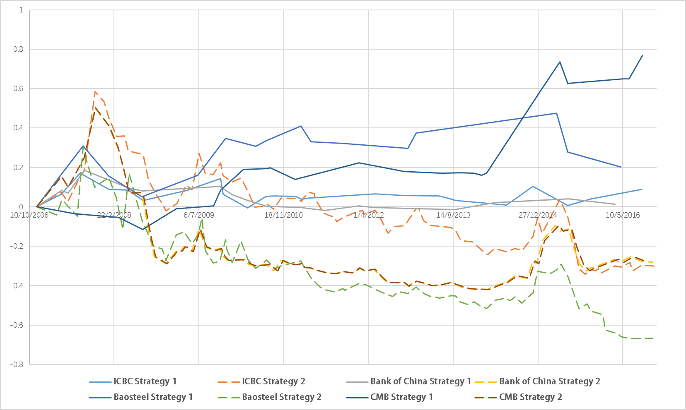**Figure 1a: Return rate of MACD-ADX Mixed Strategy and Pure MACD Strategy for 4 Shanghai Index constituent stocks**

**Strategy 1: MACD-ADX Mixed Strategy**

**Strategy 2: Pure MACD Strategy**

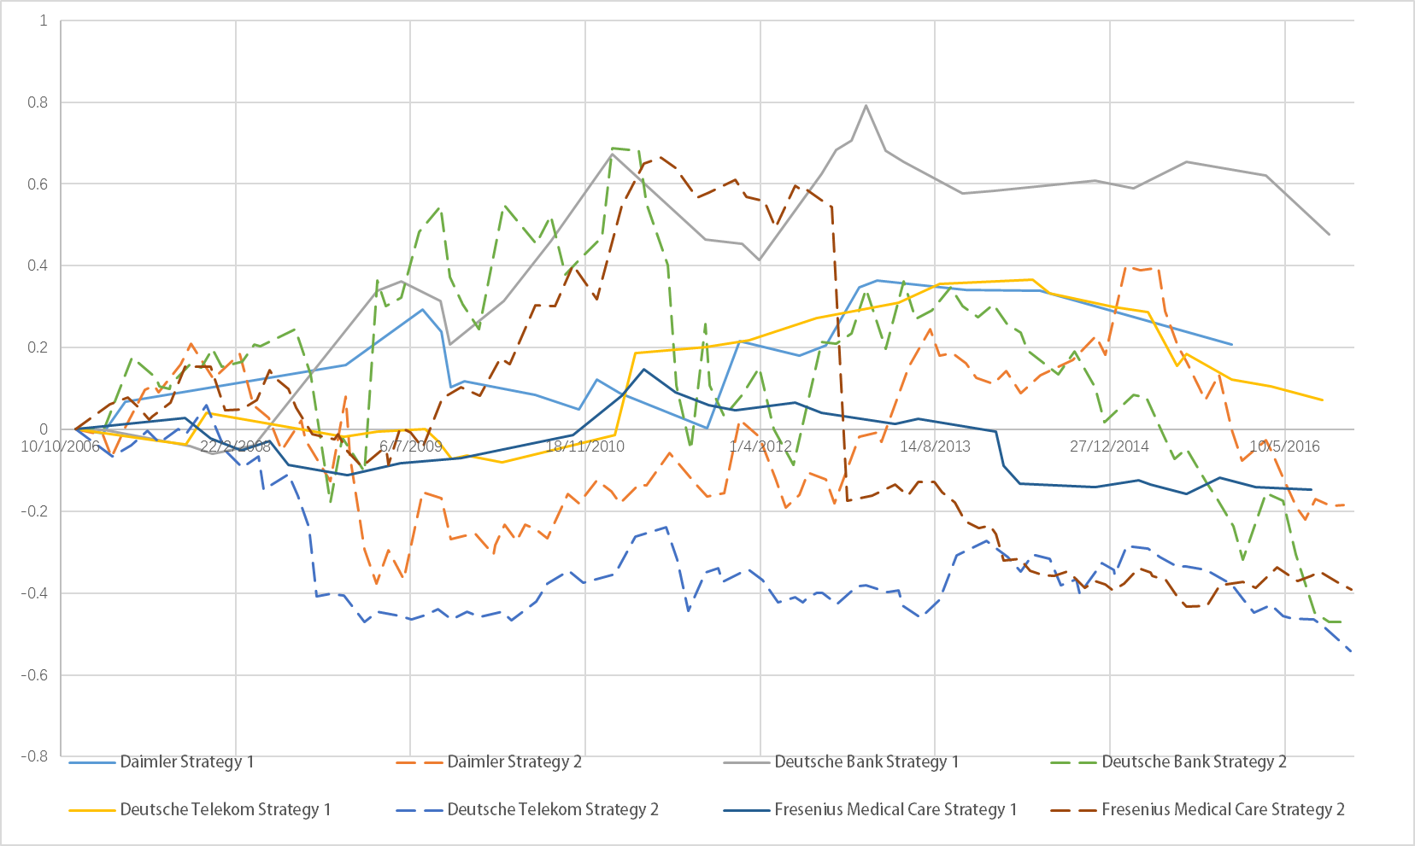**Figure 1b: Return rate of MACD-ADX Mixed Strategy and Pure MACD Strategy for 4 Dax Index constituent stocks**

**Strategy 1: MACD-ADX Mixed Strategy**

**Strategy 2: Pure MACD Strategy**

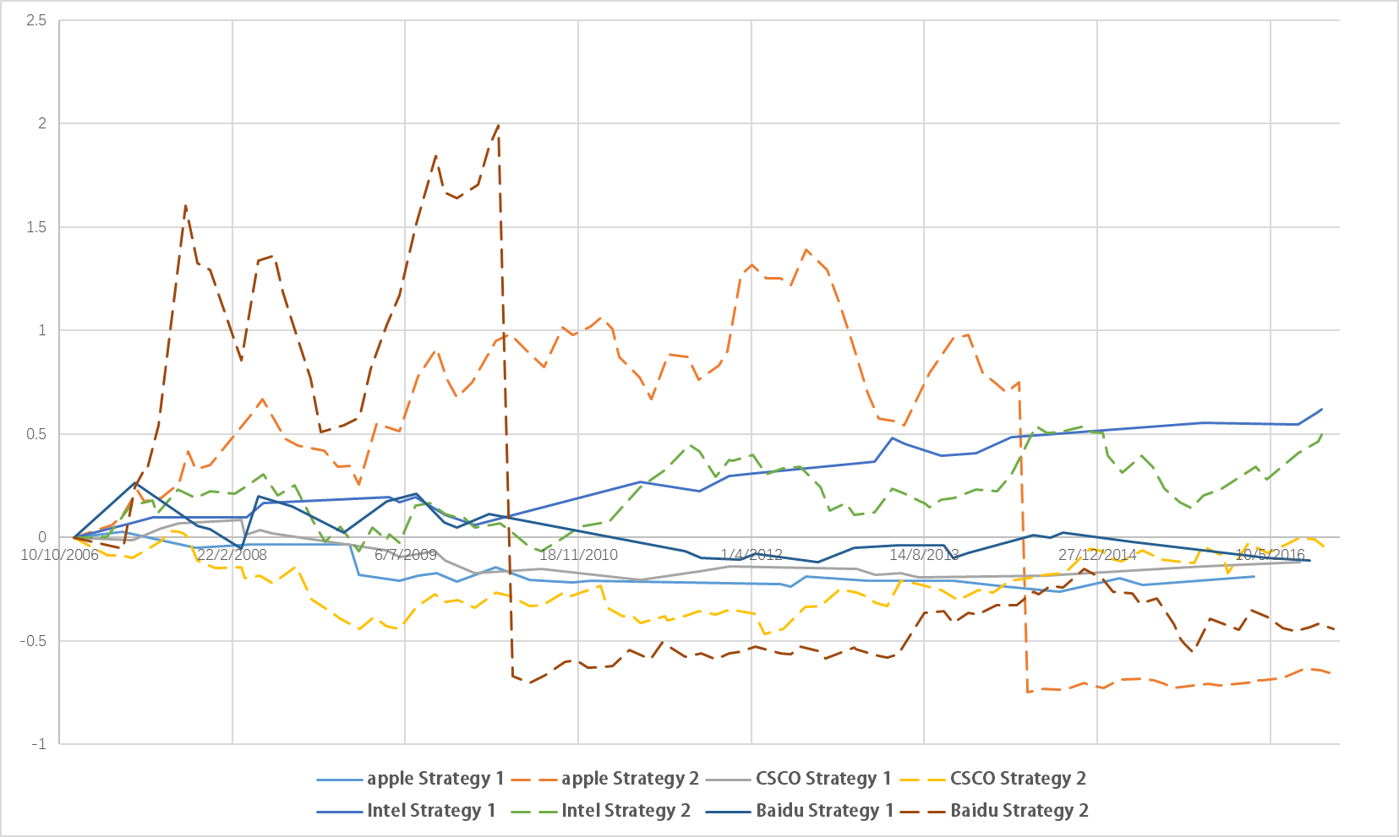**Figure 1c: Return rate of MACD-ADX Mixed Strategy and Pure MACD Strategy for 4 Nasdaq Index constituent stocks**

**Strategy 1: MACD-ADX Mixed Strategy**

**Strategy 2: Pure MACD Strategy**

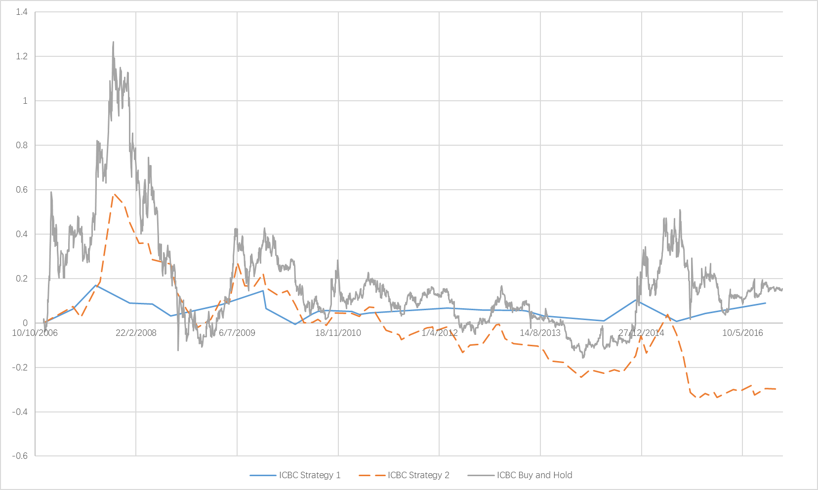**Figure 2: Return rate of MACD-ADX Mixed Strategy, Pure MACD Strategy and Buy-and-Hold for ICBC**

**Strategy 1: MACD-ADX Mixed Strategy**

**Strategy 2: Pure MACD Strategy**

It can be seen from the figure that most of the stocks under mixed strategy outperformed those under pure strategy in different market. In the early stage of trading, most of the stock under pure strategy outperformed those under mixed strategy but eventually, mixed strategy won in a long run. Take ICBC for example, in first 4 years, pure strategy performed better than mixed strategy, but in the following 6 years, the return of the pure strategy went down as the market dropped, while the mixed strategy stayed stable regardless of the market change and therefore outperformed pure strategy in the end.

Moreover, based on the above ICBC example, intuitively, it can be seen that the return rate of stocks under mixed strategy is less fluctuated than those under pure strategy, and the return of stock under mixed strategy is less likely to be affected by the market. In other words, the mixed strategy is more stable in generating return and less risky compared to pure strategy. To prove that, we conduct a one-sided f-test for the variance of monthly return for two strategies. The null hypothesis for the test is that the variance of monthly return for two strategies is equal and the alternative hypothesis is that the variance of monthly return of mixed strategy is less than the pure strategy. We take significant level α = 0.05. All 21 stocks pass the one-sided test and reject the null hypothesis, which means that we have sufficient evidence to say that the variances of monthly returns of mixed strategy is less than the pure strategy. The detailed results of the test are provided in the appendix

* + 1. **Effect of transaction cost**

To involve the effect of transaction costs into our research, we compute the annualized transaction costs as follows:

$$c_{A}= \frac{250c_{E}n}{T}$$

${where c}_{E }=the cost of each transaction$,

$n=number of transaction in the sample$,

$T=number of trading days in the sample$.

Tables 3 shows the return rate after subtracting the annualized transaction costs for each market $c_{\begin{aligned}E China \\ \end{aligned}}=1‰$, $c_{\begin{aligned}E Germany \\ \end{aligned}=}$ 6.5 $‰$ and $c_{\begin{aligned}E America \\ \end{aligned}=}$ 2.5 $‰$ repectively. The transaction cost of each can be found in the appendix2 and Shanghai Stock Exchange website (sse.com.cn).

It can be seen that the mixed strategy in general does have a better performance compared with pure MACD strategy.

**Table 3: Annualize return rate of the two strategies with transaction cost included or excluded.**



**Strategy 1: MACD-ADX Mixed Strategy**

**Strategy 2: Pure MACD Strategy**

The last two columns of Table 3 reveal the difference of return rate of the two strategies with or without transaction cost. It can be seen that by including transaction cost, the mixed strategy performed even better and outrun pure strategy even more because less transactions were conducted under mixed strategy and therefore the total amount of transaction cost is reduced. The result matches our expectation that the mixed strategy is a more cautious strategy which filters excessive signal generating from MACD compare to pure strategy.

In general, it can be concluded that mix strategy is a more profitable, risk-averse and cautious strategy compared to pure MACD strategy.

**3.2 Applicability of MACD-ADX Mixed Strategy**

For four out of seven Shanghai Index stocks and three out of seven DAX index stocks, the MACD-ADX Mixed Strategy beats the buy-and-hold strategy in annual rate of return according to Table 4. The MACD-ADX Mixed Strategy even overcomes the downside market, where buy-and-hold strategy cannot profit, and returns positive profit for Bank of China and Baosteel. In contrast, the buy-and-hold strategy generates higher return than the MACD-ADX Mixed Strategy for all seven Nasdaq index stocks selected. Hence, we can conclude that the MACD-ADX Mixed Strategy is more effective in China and German market than in U.S. market.

This phenomenon can be explained by the volatility of stock markets. Retail investors own less than 30% and represent a very small percentage of US trading volume (Langevoort, 2009) while this proportion is as high as 90% in China stock market. (Xie, 2003) More retail investors and thus less institutional investors leads to China stock market being more volatile, compared with U.S. stock market. The statistics shows that the variance of return rate in China stock market is 69.28, which is much higher than 12.21, that of U.S. stock market. (Xie, 2003) Also, DAX index is one of the most volatile index in the world. We can conclude that China and Germany stock markets are more unstable than U.S. stock market. Since our MACD-ADX Mixed Strategy weighs more on risk-aversion through checking both the trend by ADX and trading signal by MACD, this strategy is able to avoid some degree of losses caused by market oscillation because only when strong increasing trend is confirmed will buying happens while best buying or selling point may be missed due to the lag of trend judgement, which explains perfectly the different performance of the MACD-ADX Mixed Strategy in U.S., Germany and China stock market. In conclusion, the MACD-ADX Mixed Strategy tends to perform better for more volatile market and stocks. This conclusion can also be supported by conducting a simple linear regression between the variance of monthly return rate from the buy-and-hold strategy, saying, the price change rate of every stock and their relative return rates calculated as the ratio between one stock’s annual return rate from MACD-ADX Mixed Strategy and that from buy-and-hold strategy, which are reported in Table 4 below. The regression reports a monomial coefficient of 0.347 with its p-value being 0.05%, which means that there exists a credible positive correlation between the volatility of stocks and its return under our MACD-ADX Mixed Strategy.

**Table 4: Variance and relative rate**



**4. Reflection and Limitations**

Due to the time limitation, the sample of stocks tested in our paper is not large enough, which may lead to our report being less convincing. Besides, during the sampling process, we select stocks based only on their capitalization. However, some companies which had experienced capital restructuring or suspension in the past ten years are not excluded from our sample. This may result in significant price change which we do not take into consideration. We hope these limitations can be polished by later researchers and our findings can be further developed.

**Appendix 1:**

**Appendix 2:**

|  |  |
| --- | --- |
| 外國市場證券服務收費表 | |
| 證券交易服務 | 收費 |
| 美國股票 | |
| 佣金 | 成交金額0.25%, 最低美元30元 |
| 美國證監會收費 | 交易金額0.00224% (只限沽盤) |
| 預托證券費 | 於截止過戶日收取每股0.01 - 0.05 美元 (代發行商收取) |
| 托管費 | 免費 |
| 加拿大股票 | |
| 佣金 | 成交金額0.50%, 最低加元150元 |
| 托管費 | 免費 |
| 澳洲股票 | |
| 佣金 | 成交金額0.50%, 最低澳元100元 |
| 托管費 | 免費 |
| 德國股票 | |
| 佣金 | 成交金額0.65%, 最低100歐羅 |
| 交易徵費 | 按不同德國交易所政策而定 (代收取) |
| 托管費 | 免費 |
| 台灣股票 | |
| 佣金 | 成交金額0.30%, 最低台幣1500元 |
| 銷售稅 (只限股票沽盤) | 股票: 成交金額0.30%  於台灣證交所的交易所買賣基金: 成交金額0.10% |
| 交易徵費 | 台幣250元 |
| 托管費 | 投資組合總值0.12% / 12 ( 最低收費港幣 60 元, 按月尾收取) |
| 新加坡股票 | |
| 佣金 | 成交金額0.30%, 最低新加坡元100元 |
| 結算費 | 成交金額0.04%, 最高為新加坡元600元 |
| 交易費 | 成交金額0.0075% |
| 托管費 | 免費 |

**Reference**

Lee, J. Y., & Hwang, S. M. (2016). Efficient Utilization Condition of MACD on Stock Market and Nontrend Status Detecting Indicatior. Indian Journal of Science and Technology, 9(24).

Gujral & Ashwani (2005). ADX: the key to market trends. Futures, 34(6), 34.

Kotowski, J. F., Szlachcic, E., & Wa, P. M. (2010). Portfolio selection based on technical trading rules optimized with a genetic algorithm. In 2010 IEEE 14th International Conference on Intelligent Engineering Systems (pp. 19-24). IEEE.

Javanmardi, L. & Lawryshyn, Y. (2016). A new rank dependent utility approach to model risk averse preferences in portfolio optimization. Annals of Operations Research, 237 (1), 161 -176.

Roll, R. (1992). Industrial structure and the comparative behavior of international stock market indices. The Journal of Finance, 47(1), 3-41.

交易費用：上海證券交易所收費及代收稅費一覽表. (n.d.). Retrieved from https://biz.sse.com.cn/sseportal/ps/zhs/sczn/jyfy2.shtml

Donald C. Langevoort, The SEC, Retail Investors, and the Institutionalization of the Securities Markets, 95 Va. L. Rev. 1025, 1026 n.4 (2009).

謝百三. (2003). 《證券市場的國際比較:從國際比較看中國證券市場的根本性缺陷及其矯正（上）》. 清華大學出版社